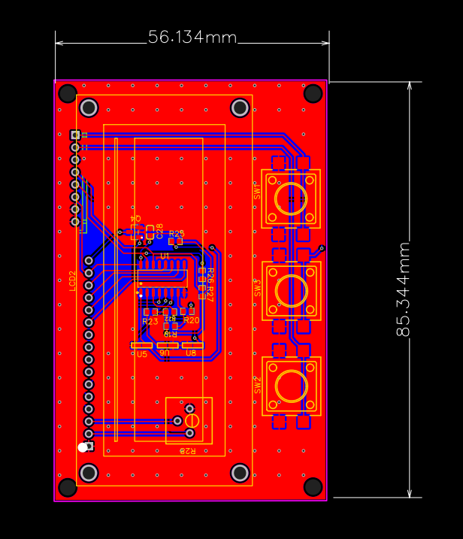
3
2
1

1.Calibrator connector (board draws power from transmitter board).
2.LCD provision
3. Control buttons

